A Binary Search Tree (BST)

Assignment
Explore BST: https://visualgo.net/en/bst

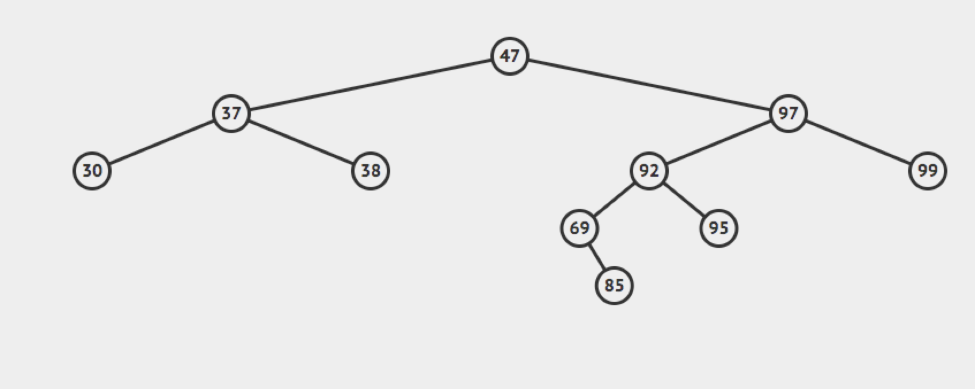

Solution:
https://replit.com/@rohitbhardwaj/Binary-Tree-Problems#BinarySearchTree.java

